|  |  |
| --- | --- |
| EGC_Black | Student Name \_\_\_\_\_\_\_\_\_\_\_\_\_\_\_\_\_\_\_\_\_\_\_  **Eastern Goldfields College**  Mathematics Methods 2017  Assignment Validation Calculator Free |
| Working Time: 20 minutes | Total Marks: 20 marks |

Question 1 (4 marks)

A box contains a total of 500 marker and highlighter pens of various colours, as shown in the table. Some of the marker pens are permanent and the rest are non-permanent.

|  |  |  |  |  |
| --- | --- | --- | --- | --- |
|  | Colour | | | |
| Type of pen | Black | Yellow | Pink | Green |
| Permanent marker | 55 | 83 | 40 | 24 |
| Non-permanent marker | 45 | 67 | 24 | 12 |
| Highlighter | 0 | 50 | 46 | 54 |

A pen is selected at random from the box. Determine the probability that it is

(a) a green pen. (1 mark)

(b) a marker pen. (1 mark)

(c) a green pen or a marker pen. (1 mark)

(d) a yellow pen, given that it is a highlighter. (1 mark)

Question 2 (6 marks)

(a) Determine $f'(x)$ when $f\left(x\right)={\left(2x-3\right)}^{2}$. (2 marks)

(b) Simplify

(i) $\frac{d}{dx}\left(4x^{2}-3x+3\right)$. (1 mark)

(ii) $\lim_{h→0}{\frac{{\left(x+h\right)}^{3}-x^{3}}{h}}$. (1 mark)

(c) Calculate the gradient of the curve $y=2x^{5}-3x^{4}$ where $x=-2$. (2 marks)

Question 3 (8 marks)

(a) The equations $x^{3}+x^{2}+ax+b=0$ and $x^{3}-bx^{2}-ax-3=0$ both have $x=-2$ as a solution. Determine the values of $a$ and $b$. (4 marks)

(b) The equation $x^{3}-x^{2}-14x+24=0$ also has $x=3$ as a solution. Determine all other solutions to the equation. (4 marks)

|  |  |
| --- | --- |
| EGC_Black | Student Name \_\_\_\_\_\_\_\_\_\_\_\_\_\_\_\_\_\_\_\_\_\_\_  **Eastern Goldfields College**  Mathematics Methods 2017  Assignment Validation Calculator Assumed |
| Working Time: 30 minutes | Total Marks: 28 marks |

Question 4 (10 marks)

The graph of two functions and a circle of radius 3 units are shown.

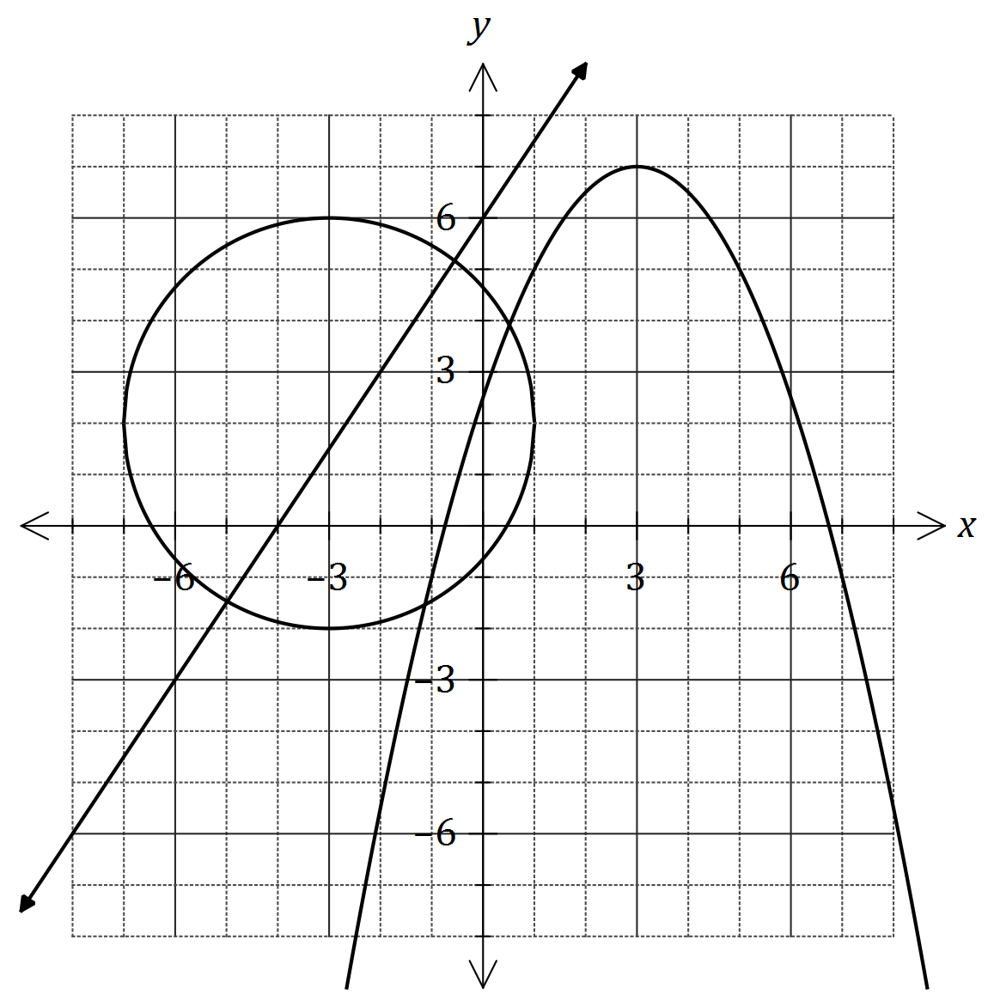

(a) One function is $f(x)=ax+b$. Determine the values of the constants $a$ and $b$. (2 marks)

(b) The relation can be written in the form $x^{2}+px+y^{2}+qy+r=0$.

Determine the values of the constants $p, q$ and $r$. (3 marks)

(c) The other function is $g\left(x\right)=cx^{2}+dx+e$.

(i) Determine the values of the constants $c, d$ and $e$, given that $g(x)$ has a maximum at $(3, 7)$. (3 marks)

(ii) State coordinates of the turning point of the graph of $y=g(x+5)$. (1 mark)

(iii) State the range of the function $y=-g(x)$. (1 mark)

Question 5 (10 marks)

(a) The graphs of $f(x)=a\sin{(bx)}$ and $g(x)=c\cos{(x+d)}$, where $x$ is in degrees, are shown below.

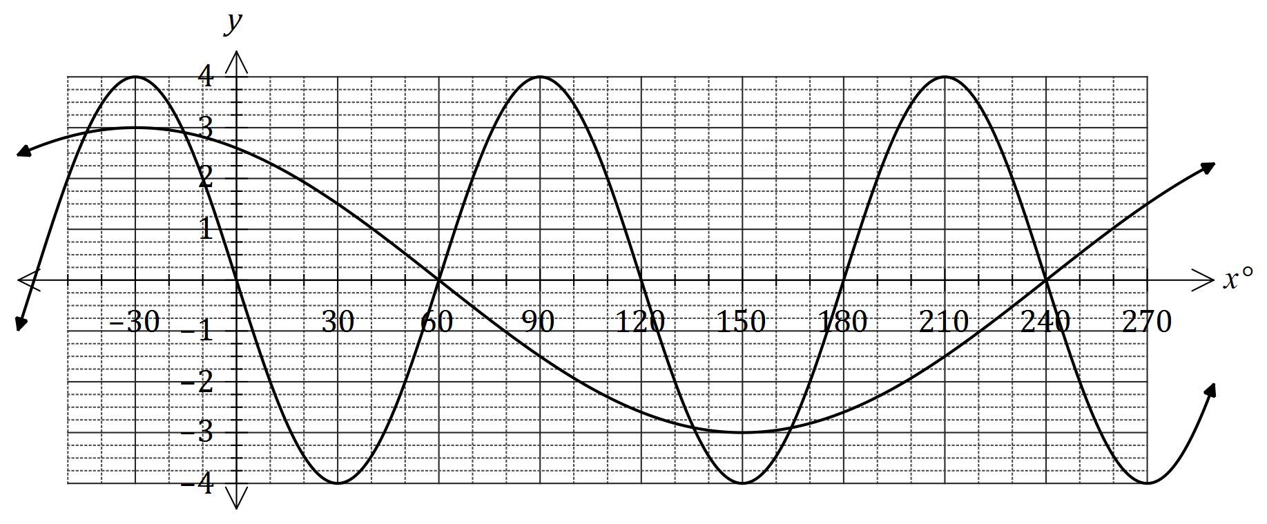

(i) Determine the values of the constants $a, b, c$ and $d$. (4 marks)

(ii) Use the graph to solve $f\left(x\right)=g\left(x\right), 0°≤x≤180°$. (2 marks)

(b) $P$ and $Q$ are acute angles with $\sin{P}=\frac{12}{13}$ and $\cos{Q}=\frac{15}{17}$. Determine the **exact** value of $\cos{(P+Q)}$. (4 marks)

Question 6 (8 marks)

The perimeter of a sector of a circle, of radius $r$ cm and central angle $θ$ radians, is 120 cm.

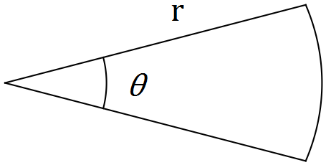

(a) Show that $θ=\frac{120}{r}-2$. (2 marks)

(b) Show that the area of the sector is given by $60r-r^{2}$. (2 marks)

(c) Use calculus to determine the maximum area of the sector and state the values of $r$ and $θ$ that achieve this maximum. (4 marks)